FBU CPU



AYŞE İREM ÇOLAK, AZİZ BURAK KAÇAR, EMRE MERCAN,

HİLAL ASYA AKBAŞ, MERT SARI

Fenerbahçe Üniversitesi

Bilgisayar Mühendisliği

İstanbul, Türkiye

e-mail: {ayse.colak,aziz.kacar,emre.mercan,hilal.akbas,mert.sarı}@fbu.edu.tr.

ABSTRACT

In this project, we have actively used all the knowledge we have learned during the term, we have produced solutions to the problems we have encountered, depending on the achievements we have achieved in the lesson, and we have completed the given processor design project.

KEYWORDS

FPGA, CPU

**INTRODUCTION**

Our project is about designing processors. The processor requested from us should perform operations such as storing incomingdata, using incoming data, deleting data, addition, subtraction and multiplication. Thanks to these features, the designed processor gives us processing speed and power.

**SYSTEM ARCHITECTURE**

We used the Avionchip company’s verilog description language tool for our processor design, so we had the opportunity to simulate our processor on the system without the need for an FPGA.

**SOFTWARE**

During the processor development process, we used software such as notepad++ along with Avionchip company’s verilog description language tool to better understand the program and write the program code effectively.

**RESULTS**

**TEST CASE 1:**

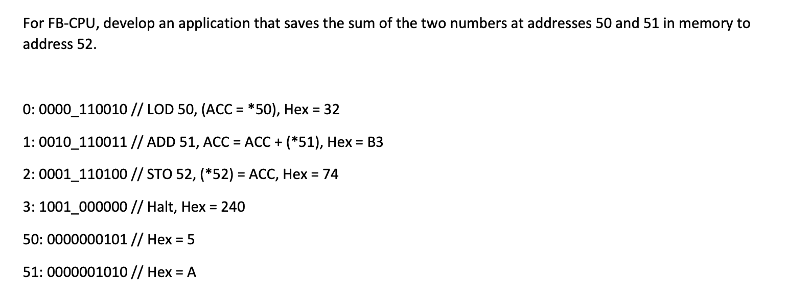

**TEST CASE 2:** 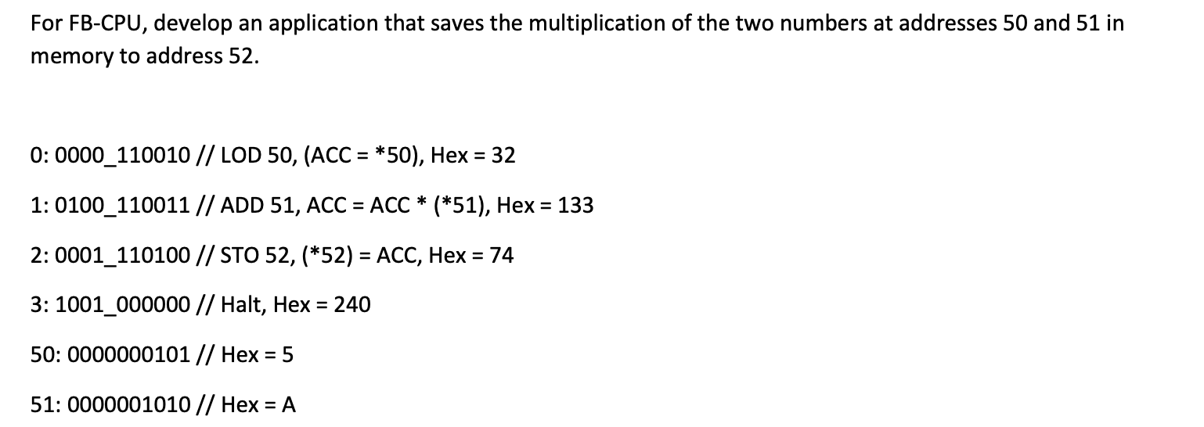

**TEST CASE 3:**

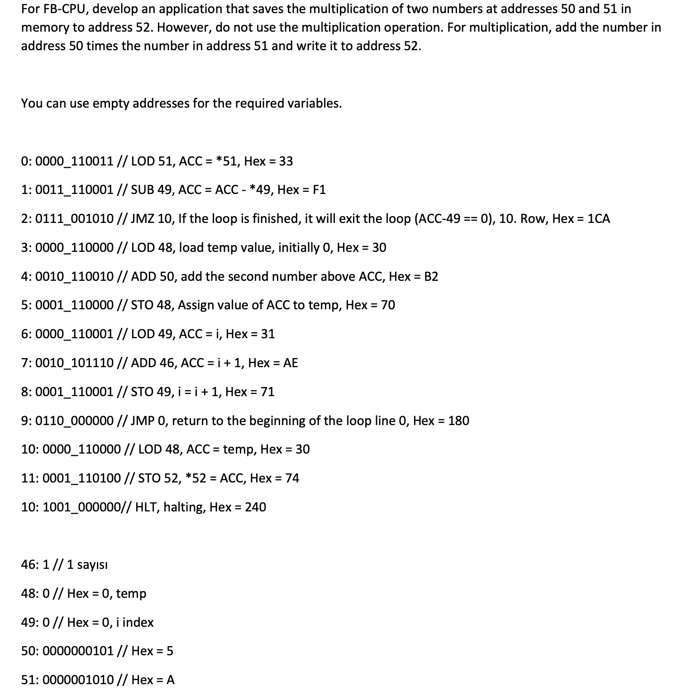

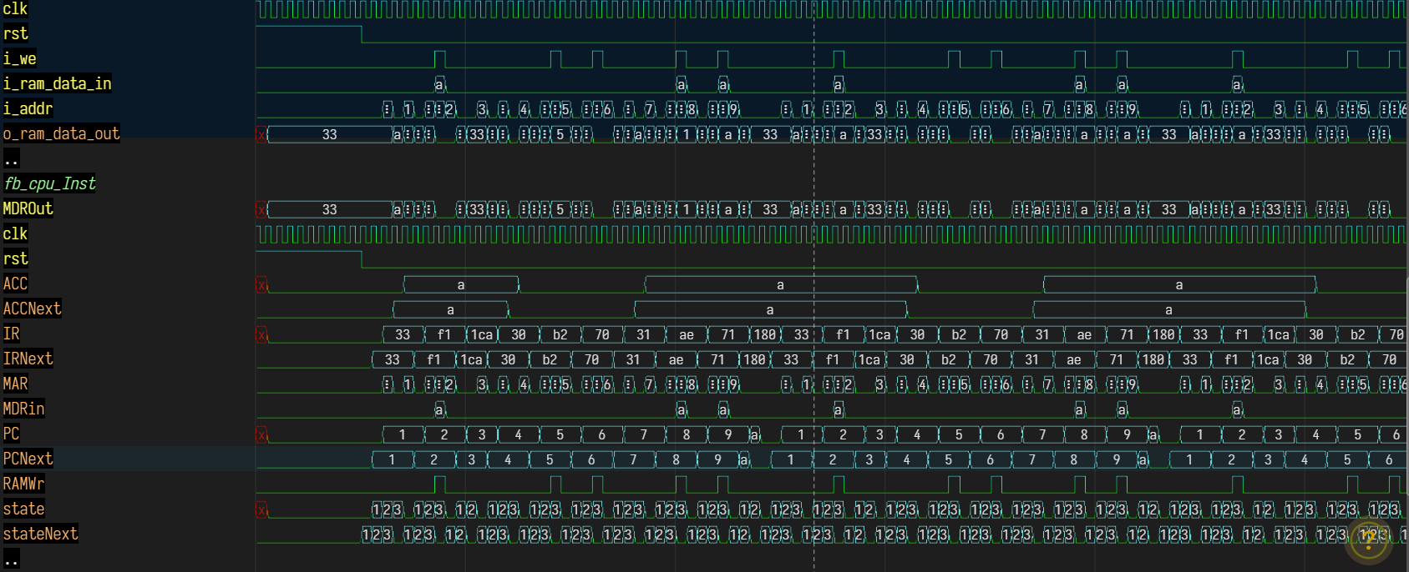

**PROJECT TEAM**

* **AYŞE İREM ÇOLAK**
* **210304001**
* **HİLAL ASYA AKBAŞ**
* **220304012**
* **AZİZ BURAK KAÇAR**
* **210304042**
* **EMRE MERCAN**
* **210304015**
* **MERT SARI**

**YOUTUBE VİDEO https://youtu.be/uXR618x9itY?si=Tez2PSU00mG0g49d**

**GitHub Link**

**https://github.com/Azizburak2/FBU-CPU-PROJECT**

**RESOURCES**

[**http://www.levent.tc/files/courses/digital_design/lectures/lec10/BLM201_hafta10_fb_cpu.pdf**](http://www.levent.tc/files/courses/digital_design/lectures/lec10/BLM201_hafta10_fb_cpu.pdf)

[**http://www.levent.tc/files/courses/digital_design/project/BLM201_proje_spesifikasyonlari.pdf**](http://www.levent.tc/files/courses/digital_design/project/BLM201_proje_spesifikasyonlari.pdf)

[**https://www.mcu-turkey.com/wp-content/uploads/2013/12/islemci_tasarimi_ve_asamalari-1.pdf**](https://www.mcu-turkey.com/wp-content/uploads/2013/12/islemci_tasarimi_ve_asamalari-1.pdf)

[**https://stringfixer.com/tr/Microprocessor_design**](https://stringfixer.com/tr/Microprocessor_design)

[**https://en.wikipedia.org/wiki/Arithmetic_logic_unit**](https://en.wikipedia.org/wiki/Arithmetic_logic_unit)

[**https://www.britannica.com/technology/arithmetic-logic-unit**](https://www.britannica.com/technology/arithmetic-logic-unit)